Land Registry System for Bangladesh: Methodology
This section outlines the methodology for developing a blockchain-based land registry system in Bangladesh, incorporating visual diagrams for clarity.
1. System Architecture
The system will follow a multi-tier architecture, separating concerns for security and scalability.
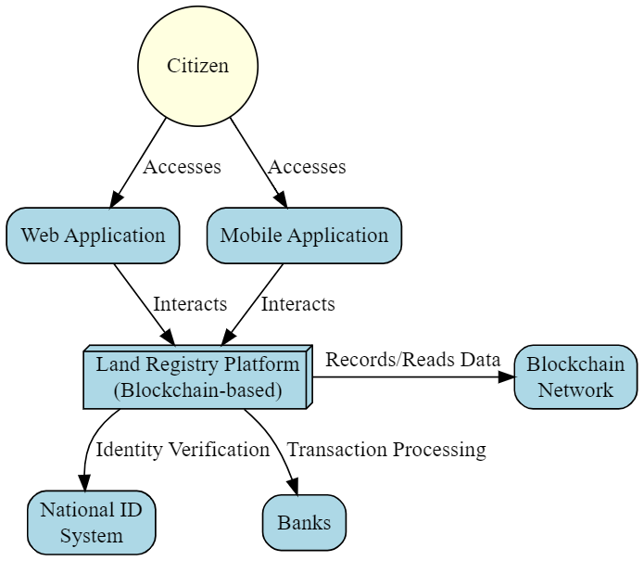
- [Figure 1: System Architecture Diagram] Shows the main components (WebApp, Mobile App, Application Server, Blockchain Network, Database, External Systems) and their interactions.
2. Cloud Architecture
The system will be deployed on a cloud platform (e.g., AWS, Azure, GCP) for flexibility and reliability.

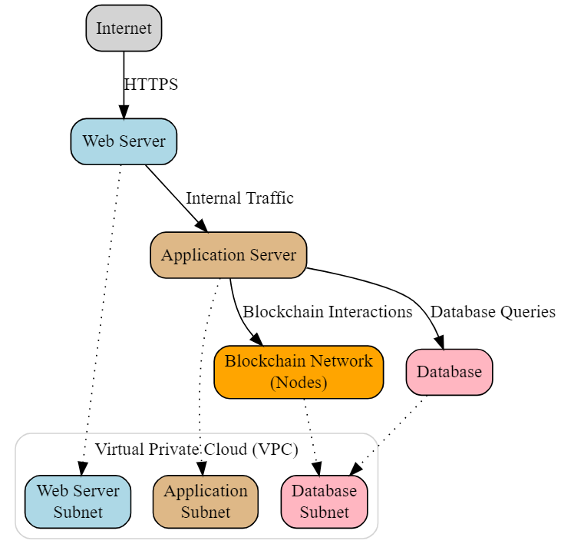
- [Figure 2: Cloud Architecture Diagram] Illustrates the deployment of components within a Virtual Private Cloud (VPC), including subnets for web servers, application servers, and the database.
3. Data Modeling

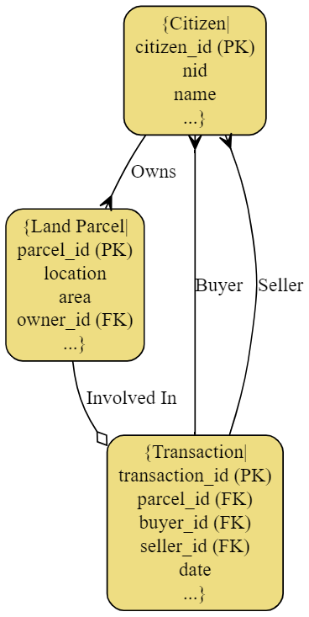

- [Figure 3: Entity Relationship Diagram (ERD)] Represents the key entities (Citizen, Land Parcel, Transaction, Document, etc.) and their attributes, relationships, and cardinality.
4. Security Design
Security is paramount. The following measures will be implemented:

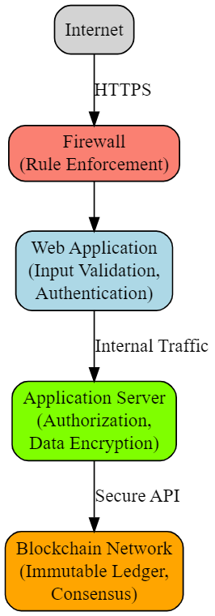

- [Figure 4: Security Diagram (Annotated)] Shows security measures integrated into the architecture (firewall, authentication, authorization, data encryption on the App Server, blockchain immutability).
5. Process Flows

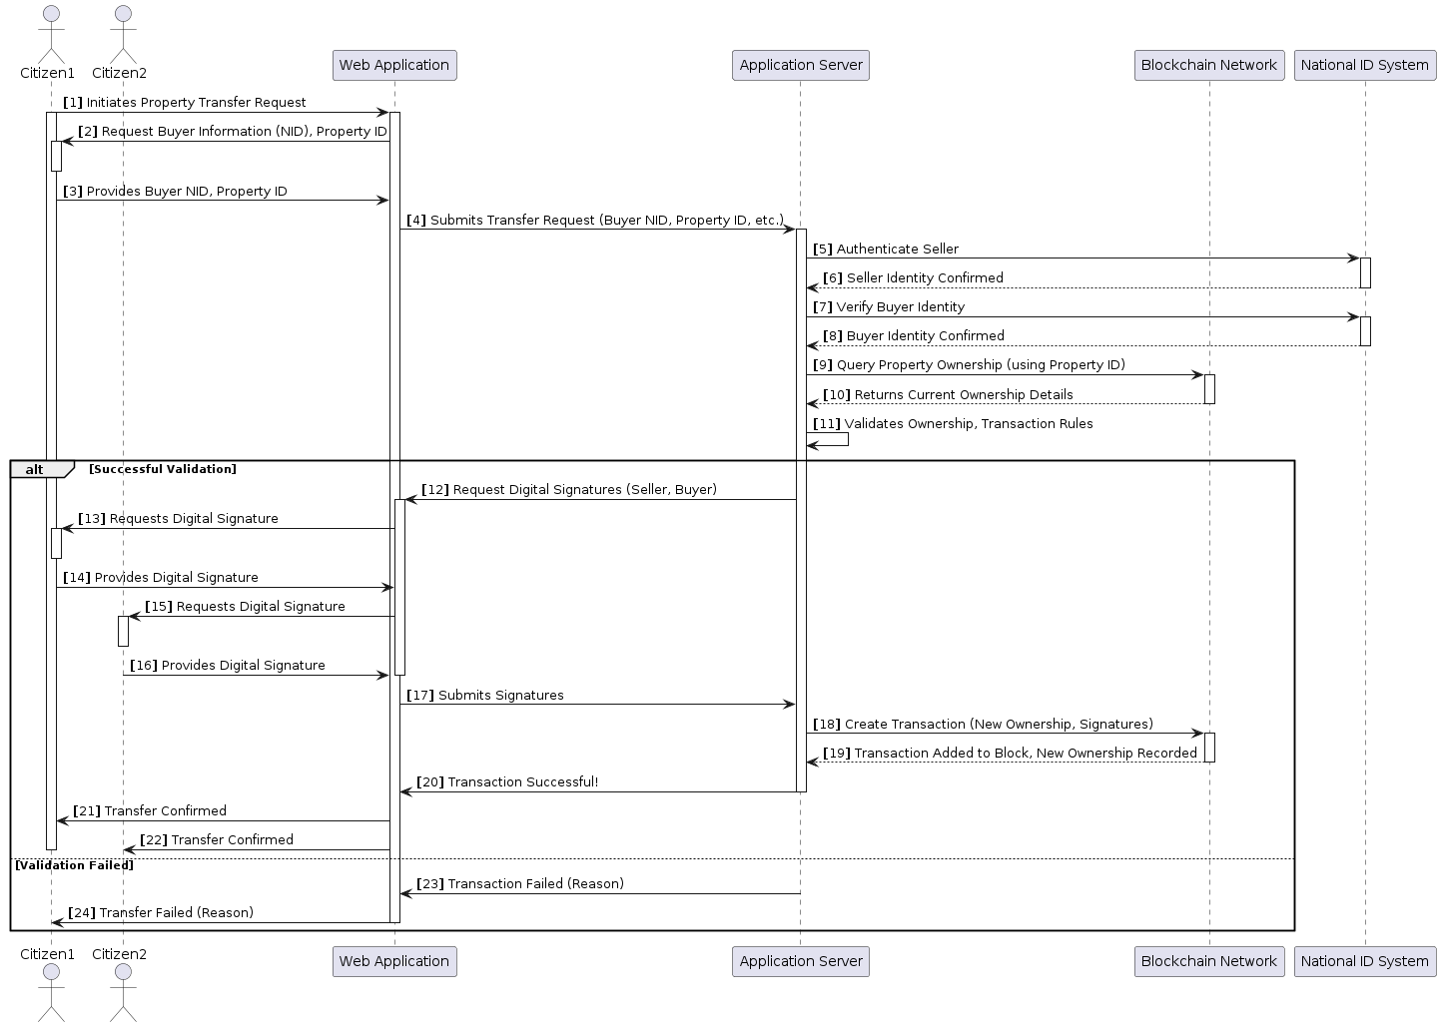

- [Figure 5: Sequence Diagram] Illustrates a detailed sequence diagram for the "Property Transfer" use case. This diagram depicts the message flow and interactions between actors (Seller, Buyer), system components, and the blockchain.
6. Deployment & State Management

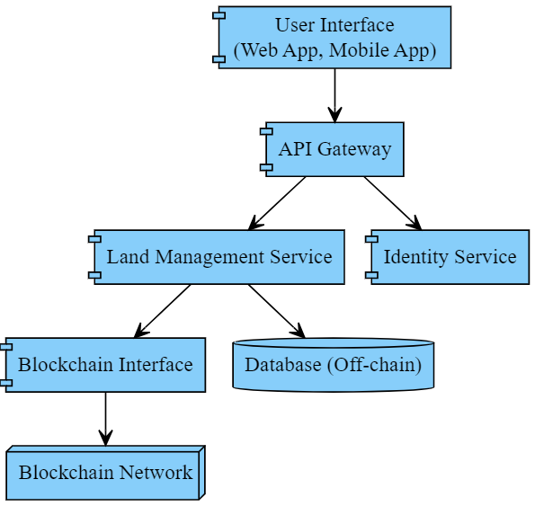

- [Figure 6: Deployment Diagram (Conceptual)] Provides a high-level overview of the physical deployment of the system, including the user's devices, network infrastructure, servers, and the blockchain network.

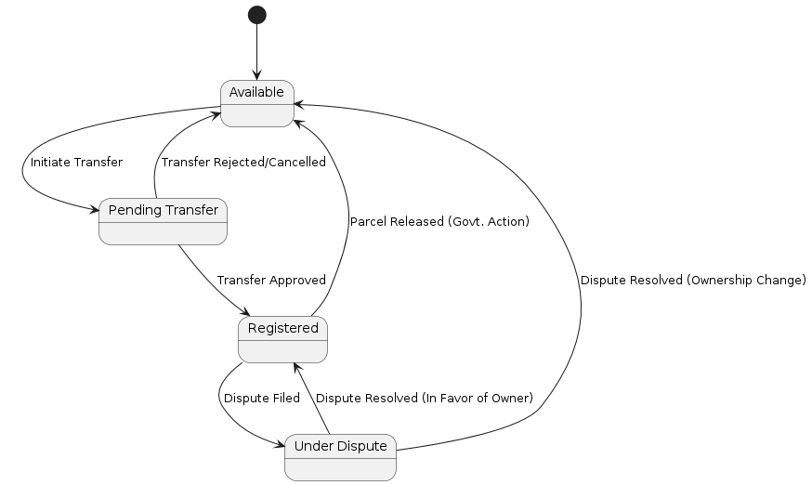

- [Figure 7: State Machine Diagram] Models the lifecycle of a "Land Parcel" entity, depicting its various states (Available, Pending Transfer, Registered, Under Dispute) and the transitions between them.
7. Implementation and Testing
- Use Agile development methodologies with iterative sprints.
- Develop and rigorously test each component with unit tests, integration tests, and system tests.
- Conduct security audits and penetration testing to identify and address vulnerabilities.
8. Pilot and Rollout
- Implement a pilot project in a limited area to gather feedback and refine the system.
- Develop training programs for government officials, citizens, and other stakeholders.
- Gradually roll out the system nationwide, ensuring widespread adoption.
Remember: You would replace the "[Figure X]" placeholders in this methodology with the actual diagrams you create. Using visual tools and designing clear and informative diagrams is crucial for communicating the system design and development process effectively.

